# [KindWords] Site Plan

## [Carter Ouzts]

## WDD 130

## Overview

### Purpose

[To spread kindness and joy to all]

### Audience

[Anyone who is looking for a kind word to either share or lighten their own mood]

## Branding

### Website Logo

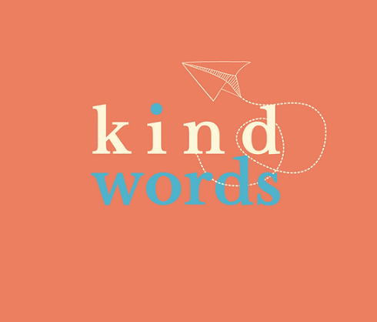

## Style Guide

### Color Palette

|  |  |  |  |
| --- | --- | --- | --- |
| **Primary** | **Secondary** | **Accent 1** | **Accent 2** |
| **#ed7e62** | **#4cb4ce** | **#fff7d6** | **#fff7d6** |

### Typography

#### Heading Font: [times new roman]

#### Paragraph Font: [Arial]

### Navigation

Home Page2 Page3

**Content**

[This space exists to slow down the fast parts of life. We believe that gentle reminders—tiny, bright moments—can shift a day, lift a heart, or simply make someone feel seen.  
Whether you’re here for encouragement, calm, or a soft reset, may these words meet you right where you are.]

**About**

Why do we run this site?

This website was created as a soft place to land. Life can feel fast, loud, and demanding, and sometimes all a person needs is a gentle reminder that they matter. Kind Words exists to offer small moments of comfort, encouragement, and warmth—freely, quietly, and without expectation.

Images:

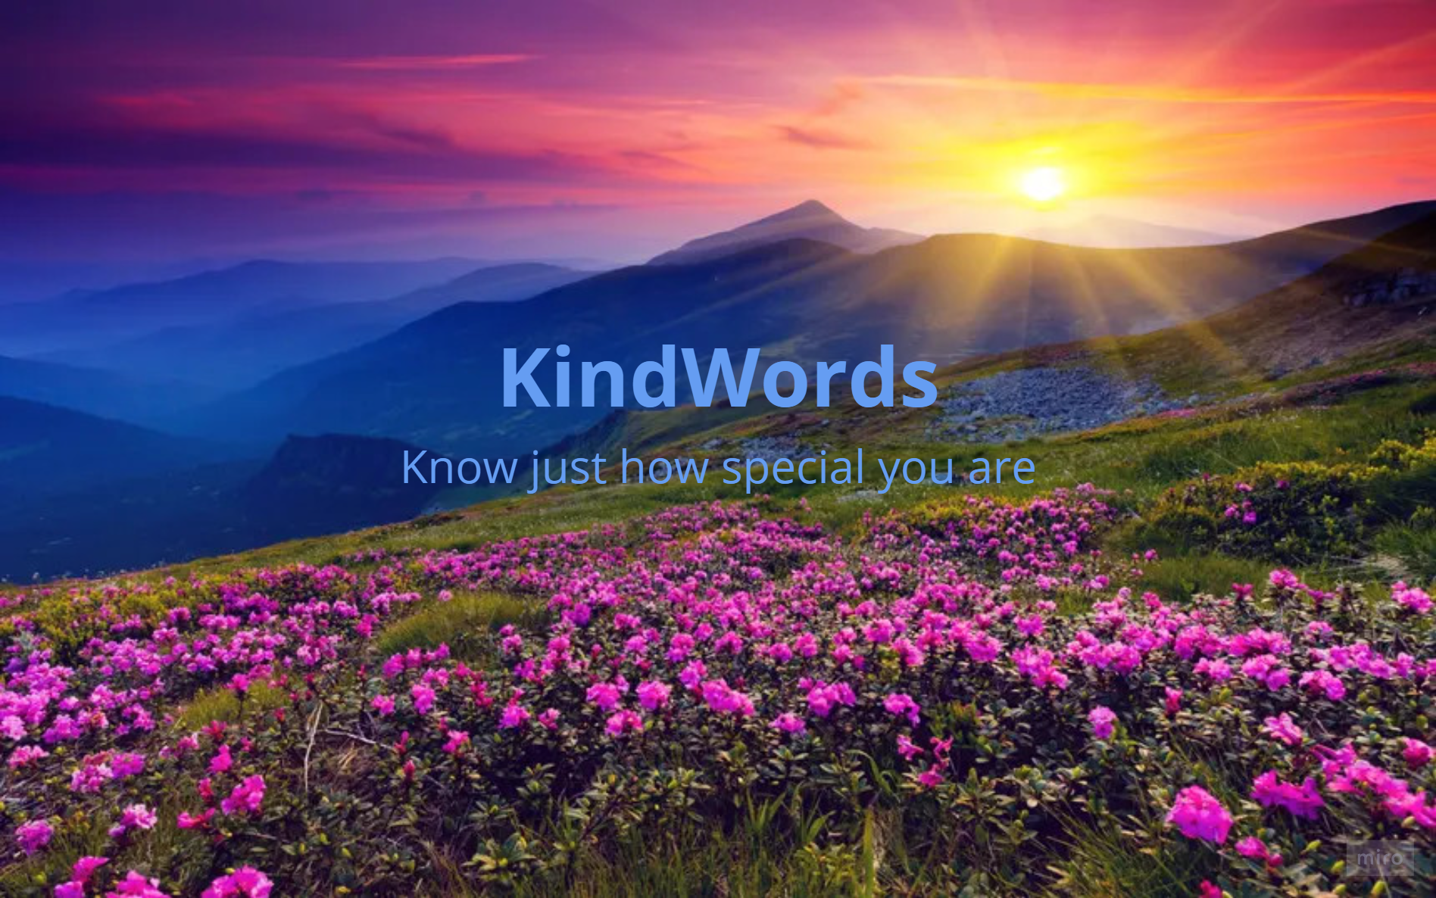



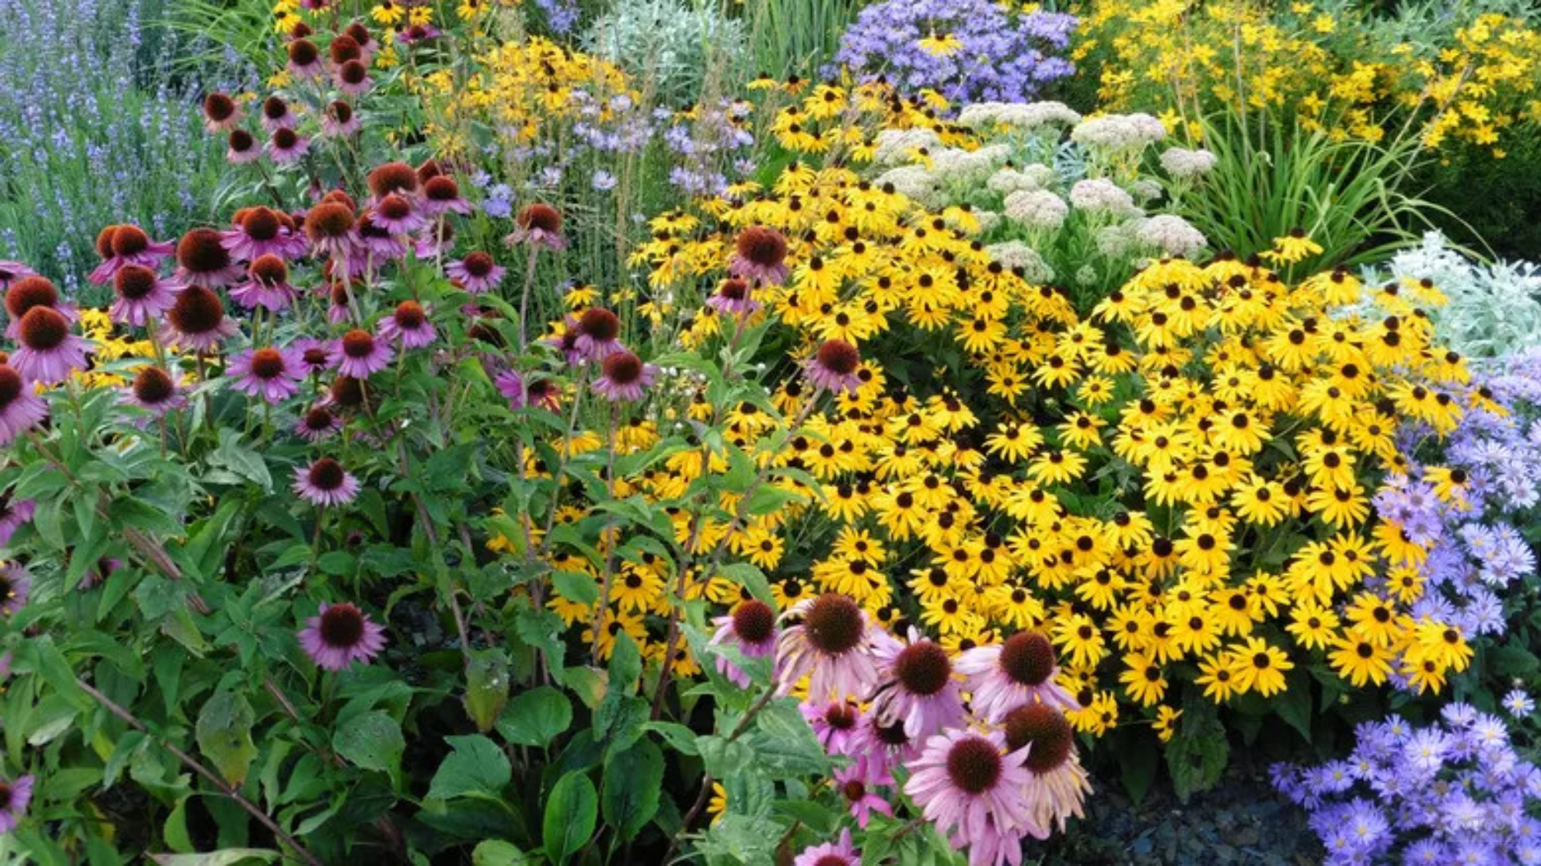





**• *You are doing better than you think.***

**• *The world is softer because you’re in it.***

**• *You don’t have to be perfect to be loved.***

**• *Your pace is the right pace.***

**• *Someone out there is smiling because of something you once said.***

**• *Rest is productive too.***

**• *You deserve good things without having to earn them.***

**• *Your presence is a gift, even on quiet days.***

**Wireframes**

### Home

